Don Bosco Boys Camp
“To make the young delight in God”

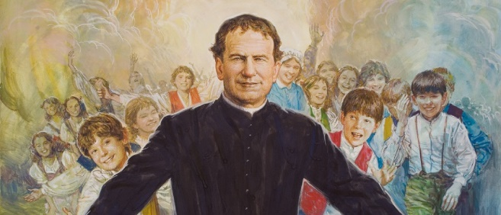
Since 1997
July 21, 2024 – August 1, 2025

Sponsored by Holy Family Academy
Located at Christ the King Parish in Concord, NH

The Don Bosco Boys Camp offers a fun, faith-filled environment for boys 6 to 14 to form healthy friendships, develop character, and grow closer to Christ! Activities include the following:
Capture the Flag | Barbarian Outpost | Gauntlet
Arm Wrestling | Brain Teasers & Riddles | Game Room
Stories about the Saints | Wrestling Matches | Mass on Wednesday
Building Towers | WW II Calisthenics | Daily Angelus
Gatorball | Morning Visit with Jesus | Magic Tricks
Decade of the Rosary | Dodgeball | Tug-O-War
Spartan Race  Kayak Races | Pinewood Cars  Blob Tag | Skits  Chariot Race

- The DBBC meets at Christ the King Parish in Concord, Monday through Friday from 9-4 PM.
- Campers 13 - 14 may be Counselors in Training (CITs); 15-year-olds may volunteer to be CITs.
- The cost to attend Don Bosco Boys Camp is $200 per week; this is non-refundable.
- The state of NH’s Rekindling Curiosity program will cover some/all costs for families who qualify..
- Contact Teresa Rouillard, Admissions Director, at trouillard@holyfamilyacademy.org for help with applying for the camp and for the Rekindling Curiosity scholarships.
- Scholarships & family rates are available! Make checks payable to Holy Family Academy.
- Don Bosco Boys Camp is the only Catholic day camp in NH for boys ages 6 to 14.
- Questions about the Don Bosco Boys Camp? Contact Camp Director, Mark Gillis, at (603) 545-5912.
- Register your child at www.DonBoscoBoysCamp.org

Registration Deadline June 15, 2025

